9.26:
(note that since 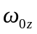 and 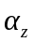 are given in terms of revolutions, it’s not necessary to convert to radians). . c) Here, the conversion to radians must be made to use Eq. (9.13), and
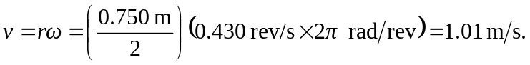

d) Combining equations (9.14) and (9.15),

